Name : Muhammad Haseeb Lab Task:02 Class : BSAI(3A)
Answer 01).
PEAS Specifications for Two Intelligent Agents
Delivery Robot and LLM-Based Student-Support Agent
PEAS is a framework used to describe an intelligent agent’s task environment. It stands for Performance measure, Environment, Actuators, and Sensors. The specifications below identify concrete examples for each component and state the operational assumptions.
1. PEAS Specification: Delivery Robot
Task: autonomously transport parcels or small items from a dispatch point to a specified recipient or drop-off point while avoiding collisions and respecting site rules.
PEAS component | Specification and concrete entries
Performance measure (P) | • Successful delivery to the correct destination  • Safe operation with zero collisions or injuries  • Delivery time and route efficiency  • Low energy use and few failed delivery attempts
Environment (E) | • Indoor corridors, lifts, doorways, and reception areas  • People, other robots, carts, and temporary obstacles  • Delivery stations, recipient locations, and charging docks  • Variable lighting, floor surfaces, and Wi-Fi coverage
Actuators (A) | • Drive motors and steering mechanism to move and turn  • Brakes or motor stop control for safe stopping  • Robotic compartment latch or small gripper to secure/release a parcel  • Speaker, screen, or indicator lights to notify recipients
Sensors (S) | • RGB/depth camera to detect people, doors, and obstacles  • LiDAR or ultrasonic sensors to estimate distance to obstacles  • Wheel encoders and IMU to estimate movement and orientation  • GPS outdoors or mapped localization/beacons indoors; battery and parcel-door sensors

Constraint / performance trade-off
The robot must balance speed against safety. Moving faster can improve delivery time, but it reduces the time available to react to pedestrians and unexpected obstacles. The robot should therefore slow down in crowded or uncertain areas, even if this increases the average delivery time. Battery capacity and payload weight also limit route length and speed.
2. PEAS Specification: LLM-Based Student-Support Agent
Task: answer student questions about coursework, explain concepts, help plan study activities, and direct students to appropriate university services. The agent supports learning; it does not replace instructors, academic advisors, or emergency services.
PEAS component | Specification and concrete entries
Performance measure (P) | • Accuracy and relevance of answers, including correct acknowledgement of uncertainty  • Clear explanations that help students understand rather than merely copy answers  • Response time and successful resolution of common questions  • Privacy, respectful language, accessibility, and appropriate escalation for high-risk situations
Environment (E) | • Students using a web chat or university learning portal  • Courses, assignment instructions, timetables, and approved learning resources  • Different student knowledge levels, languages, devices, and network conditions  • University policies, academic-integrity rules, and support-service hours
Actuators (A) | • Generate text responses, summaries, examples, and step-by-step explanations  • Ask clarifying questions and provide links to approved resources  • Create study plans, reminders, or practice quizzes when those features are enabled  • Refer a student to a human instructor, advisor, counsellor, or emergency support when appropriate
Sensors (S) | • Read the student’s typed message and conversation context  • Receive uploaded text or documents only if file upload is enabled  • Retrieve approved course materials through a read-only search/retrieval tool, if connected  • Receive limited account/course metadata only when permission and integration explicitly allow it
Operational assumptions and tool access
Assumptions: the agent is accessed through a web-based chat; it uses an LLM to interpret questions and draft responses; it may not know current course-specific facts unless those facts are supplied in the conversation or retrieved from an approved source. It should state uncertainty and avoid inventing deadlines, grades, policies, or citations.
Tools available in this specification (assumed, not guaranteed in every deployment):
A read-only search/retrieval tool connected to instructor-approved course notes, FAQs, and university policy pages.
A calculator for arithmetic and checking simple numerical results.
A document/text reader for files the student intentionally uploads, subject to file-size and format limits.
A link-out or referral function that displays official university contact details and student-support resources.
No direct access to student records, grades, email, learning-management-system write actions, payment systems, or private files unless a separate authorized integration is explicitly added.
Constraint / performance trade-off
A more personalized answer may require more student data, but collecting or retrieving extra data increases privacy and security risks. The agent should use the minimum information needed and only authorized tools. It must also balance speed with reliability: when a question depends on current university rules, retrieving an approved source or asking a clarifying question is better than giving a fast but unsupported answer.
3. Comparison and conclusion
Both agents use sensors to gather information and actuators to affect their environment, but their actions differ. The delivery robot acts physically, so collision avoidance, localization, and battery limits are central. The student-support agent acts mainly through information: accuracy, helpful explanations, privacy, academic integrity, and safe referral are central. In both cases, the performance measure must include safety and reliability rather than optimizing speed alone.
Assumptions at a glance
Delivery robot: operates in a mapped campus, office, or similar controlled delivery area; has obstacle sensors, navigation, and a secure parcel compartment; can stop and request human help if blocked.
Student-support agent: provides educational support through chat; uses an LLM plus only the tools listed above when actually configured; does not make official academic decisions or provide professional diagnosis.
Tool availability is deployment-dependent. The PEAS specification describes an assumed design, not a claim that every real system already has these integrations.

Answer no 02).
We need to classify both systems from Task 1 — the delivery robot and the LLM-based student-support agent — using two dimensions:
- Observability: Fully observable or partially observable.
- Action outcomes: Deterministic or stochastic.
The classification depends on the assumptions about how each system operates. A real-world environment may be more uncertain than a simplified simulator.
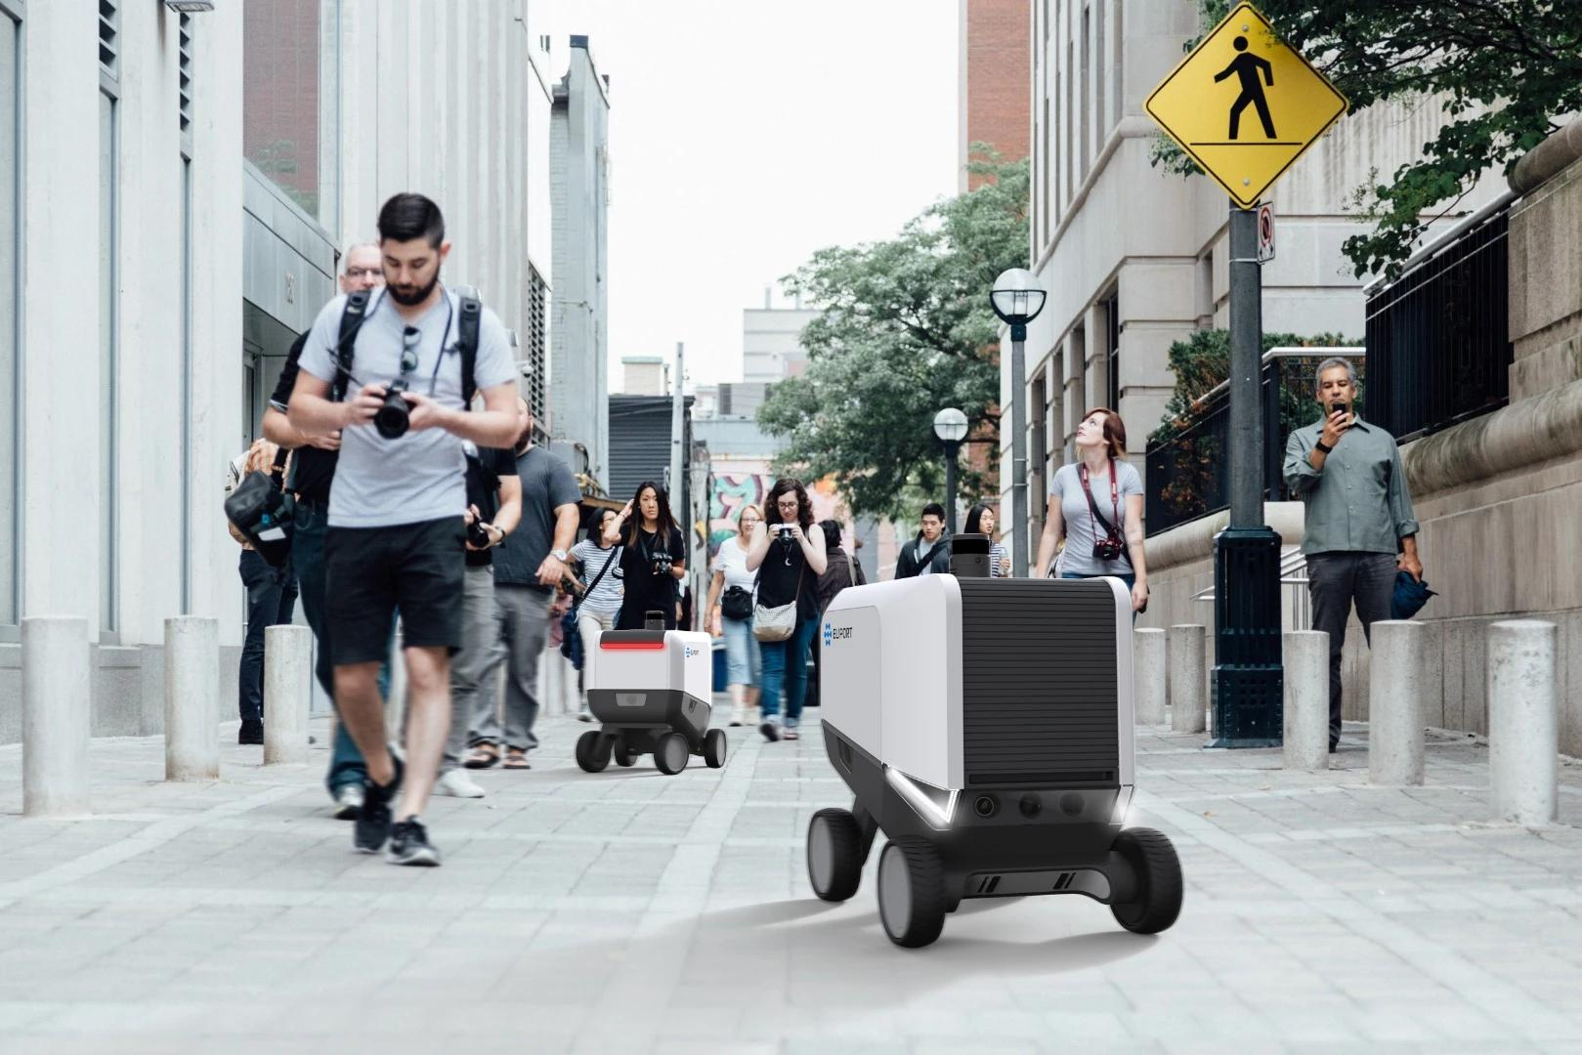
Assumption: The robot delivers packages outdoors using cameras, GPS, obstacle sensors, and a navigation system.
- Observability: Partially observable. The robot cannot observe every aspect of its environment at all times. For example, a camera may detect a pedestrian ahead, but a parked vehicle may hide another pedestrian.
- Determinism: Stochastic in the real world. The same movement command may produce different results because of slippery roads, changing pedestrian movements, weather, or sensor errors.
- Examples:
Dimension | Example
Observable variable | The obstacle detected by the robot's camera.
Hidden variable | A pedestrian hidden behind a parked vehicle.
Predictable outcome | In a simplified simulator, moving forward one grid cell always moves the robot one cell forward if the path is clear.
Uncertain outcome | In the real world, a forward movement command may result in a shorter movement because of an obstacle or wheel slippage.
- Simulator vs. real environment: In a simplified grid simulator with complete state information and fixed movement rules, the robot's environment can be fully observable and deterministic. In the real world, it is generally partially observable and stochastic.
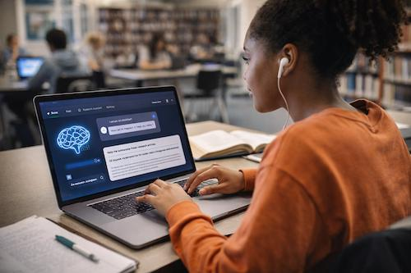
Assumption: The agent answers students' academic questions using an LLM, the student's provided information, and authorized tools such as course materials, a calculator, and a university FAQ database. It cannot access private student records unless permission and an appropriate tool are provided.
- Observability: Partially observable. The agent can observe the student's message and any supplied documents, but it may not know the student's actual understanding, intentions, emotional state, or missing course requirements.
- Determinism: Stochastic in typical real-world operation. An LLM may generate different answers to the same question, particularly when sampling is enabled. Tool failures or changing database contents may also affect results.
- Examples:
Dimension | Example
Observable variable | The question and assignment instructions provided by the student.
Hidden variable | The student's actual understanding or an unstated requirement from the instructor.
Predictable outcome | In a simplified system, a calculator tool returns the same result for the same valid input.
Uncertain outcome | An LLM may provide different explanations or produce an incorrect answer to the same question.
- Simulator vs. real environment: In a simplified simulator, the agent may receive all relevant information and use fixed rules, making it fully observable and deterministic. In a real deployment, it is generally partially observable and potentially stochastic. If the LLM uses deterministic decoding, fixed prompts, fixed tool results, and reproducible settings, its output may be repeatable; however, this does not guarantee that its answers are correct.
- Final Classification Summary
System | Observability | Action outcomes | Real-world justification
Delivery robot | Partially observable | Stochastic | Sensors cannot reveal everything, and movement is affected by changing physical conditions.
LLM student-support agent | Partially observable | Stochastic (typically) | Student context is incomplete, and LLM responses may vary or contain errors.
Answer no 03).
class ReflexACAgent:
def __init__(self):
self.previous_mode = None

def choose_mode(self, temperature, desired, occupied):

if occupied == False:
target = "OFF"
elif temperature > desired:
target = "ON"
else:
target = "OFF"

if target == self.previous_mode:
command = "No command"
else:
command = "Send command"

self.previous_mode = target

return target, command

agent = ReflexACAgent()

tests = [
(31, 30, True),
(31, 30, True),
(30, 30, True),
(27, 28, True),
(33, 30, False)
]

for temp, desired, occupied in tests:
previous = agent.previous_mode

target, command = agent.choose_mode(
temp, desired, occupied
)

print(previous, temp, desired, occupied, target, command)
output : None 31 30 True ON Send command
ON 31 30 True ON No command
ON 30 30 True OFF Send command
OFF 27 28 True OFF No command
OFF 33 30 False OFF No command

